COIMBATORE INSTITUTE OF TECHNOLOGY
(Government Aided Autonomous Institution affiliated to Anna University)
━━━━━━━━━━━━━━━━━━━━━━━━━━━━━━━━━━━━━━━━━━━━━━━━━━━━━━━━━━━━━━━━━━━━━━━━━━━━━━━━━━
PROJECT DOCUMENTATION
PayGate (Transiq)
Secure Digital Payment & Wallet Management Platform
A Scalable Full-Stack MERN Payment Gateway and Intelligent Digital Wallet System

Field | Details
Project Title | PayGate (Transiq) — Secure Digital Payment & Wallet Management Platform
Domain | Full-Stack Web Development — Digital Payments (MERN Stack)
Institution | Coimbatore Institute of Technology
Course | M.Sc. Software Systems
Semester | III
Academic Year | 2025 – 2026

Team Details (6 Members)
S.No | Name of the Student | Register Number
1
2
3
4
5
6

Project Guide / Supervisor: Prof. / Dr. ______________________________________
Signature of the Guide: ______________________________

Table of Contents

Note: In Microsoft Word, right-click the table of contents and select “Update Field” after editing the document.

1. Synopsis
The rapid digitization of banking and merchant transactions demands high-speed, secure, and fault-tolerant financial architectures. PayGate (Transiq) is an enterprise-grade full-stack digital wallet and payment gateway web platform built on the MERN (MongoDB, Express.js, React, Node.js) technology stack. The system provides end-to-end electronic fund transfers between registered customers, linked banking institutions, and beneficiaries, reinforced by automated telemetry for administrative fraud supervision and real-time error auditing.

1.1 Problem Definition
Modern digital transaction platforms suffer from two major challenges: (1) brittle client-side state leading to accidental double charges or stale balances during connectivity interruptions, and (2) absence of structured telemetry, causing failed financial operations to be silently dropped without auditable traceability.

1.2 Proposed System
- Customer Financial Portal: wallet top-ups, Smart Pockets with strict withdrawal locking, verified beneficiary directory management, and a 4-step idempotent payment checkout wizard — Beneficiary selection → Method configuration → PIN authorization → Digital receipt issuance.
- Operations & Audit Console (Admin): transaction telemetry, system health monitoring, pending payment retries, and high-severity error auditing with root-cause categorization such as INSUFFICIENT_FUNDS, BANK_TIMEOUT and FROZEN_WALLET.

1.3 Key Technologies
- Frontend: React 18 (Vite SPA), Tailwind CSS, Zustand centralized stores and Lucide icons.
- Backend: Node.js runtime, Express REST API, JSON Web Token (JWT) stateless authentication and Bcrypt hashing.
- Database: MongoDB with Mongoose ODM, ACID session transactions and schema validators.

1.4 Implementation Outcome
The platform enforces strict zero-trust role separation. Unauthenticated visitors are prevented from loading dashboard views through synchronous route guards. Transactions execute atomically, and payment failures produce automated ErrorLog records for audit recovery.

2. Objectives
- Secure Wallet & Multi-Account Banking: manage primary wallet balances alongside simulated linked commercial bank accounts (Savings, Current, NRI) within an integrated dashboard.
- Deterministic, Idempotent Payment Initiation: provide a multi-step funds transfer flow ensuring payments cannot be double-processed, overdrawn, or transferred to unverified recipients.
- Smart Pocket Micro-Budgeting: create targeted financial goal buckets with dedicated lock/unlock controls to prevent impulse spending.
- Zero-Trust Role-Based Access Control (RBAC): segregate customer and administrative privileges through signed JWT tokens, bcrypt-hashed secrets and front-end navigation guards.
- Real-time Telemetry & Auditability: capture transaction failure telemetry including timestamps, error codes, affected amounts and stack traces into an administrator-monitored ledger.

3. Scope

3.1 Functional Scope
- Authentication & Identity: user registration with input sanitization, secure login, customer/admin role separation and session clearance on logout.
- Customer Services: real-time balance inspection, pocket creation, beneficiary management, IFSC/account validation, Wallet/IMPS/NEFT/RTGS transfers and transaction-history filtering.
- Administrative Operations: system-wide transaction-volume and success-rate analytics, pending transaction resolution and error triage with LOW, MEDIUM, HIGH and CRITICAL severity levels.

3.2 Technical Scope
- Stateless REST API communicating through JSON payloads.
- Responsive interface for mobile, tablet and desktop screens.
- MongoDB hosted locally or on cloud clusters with schema-level validation.

3.3 Out-of-Scope / Future Expansion
- Physical hardware POS integration.
- Cross-border currency conversion and SWIFT settlement.
- Third-party real-bank webhook integration; current implementation uses mock banking controllers.

4. Project Description & System Architecture
PayGate (Transiq) is structured as a decoupled multi-tier web application consisting of an Express.js/Node.js API service and a React.js client. The architecture is organised into three tiers.

4.1 Client Tier — Transiq UI
- High-performance Single Page Application powered by Vite.
- Zustand stores: useCustomerStore, useRecipientStore, usePocketStore, transactionStore and logsStore.
- Root-level route protection through AppLayout, checking token validity before rendering views.

4.2 Application Server Tier — transiq-api
- Node.js / Express backend exposing versioned /api/ endpoints.
- Middleware for CORS, JSON parsing, token verification (auth.js), role validation (adminAuth.js) and centralized error interception.
- Business controllers orchestrate payment validation, PIN verification, balance deductions and atomic record insertion.

4.3 Data Persistence Tier — MongoDB
- Seven dedicated collections: users, wallets, bankaccounts, pockets, receipts, transactions and errorlogs.
- Mongoose ObjectId references and indexed lookups maintain referential integrity and efficient access.
Tier | Primary Technology | Responsibilities
Client | React 18, Vite, Tailwind, Zustand | UI rendering, state management, route protection and payment wizard
Application | Node.js, Express, REST API | Authentication, validation, payment processing, role checks and error interception
Persistence | MongoDB, Mongoose | Users, wallets, beneficiaries, transactions and telemetry

5. Database Design
The database comprises the core collections documented in the project record. The following tables retain the field-level definitions, constraints and purposes from the source.

5.1 users Collection
Field | Type | Constraints / Default | Description
_id | ObjectId | Primary Key, Auto | Unique user identifier
firstName | String | Required, Trim | User first name
lastName | String | Required, Trim | User last name
email | String | Required, Unique, Lowercase | Primary login email address
password | String | Required (Bcrypt hash) | Hashed authentication password
phone | String | Optional | Contact mobile number
role | String | Enum: customer, admin; Default: customer | System authorization role
isActive | Boolean | Default: true | Account suspension status
createdAt | Date | Auto Timestamp | Account registration timestamp

5.2 wallets Collection
Field | Type | Constraints / Default | Description
_id | ObjectId | Primary Key, Auto | Unique wallet identifier
userId | ObjectId | Required, Ref: User, Index | Owning customer reference
mainBalance | Number | Required, Min: 0, Default: 0 | Available liquid funds (INR)
currency | String | Default: INR | Standard currency ISO code
isFrozen | Boolean | Default: false | Security freeze status flag
createdAt | Date | Auto Timestamp | Wallet generation timestamp

5.3 pockets Collection
Field | Type | Constraints / Default | Description
_id | ObjectId | Primary Key, Auto | Unique pocket envelope ID
userId | ObjectId | Required, Ref: User | Owning customer reference
name | String | Required, Trim | Pocket goal name
targetAmount | Number | Required, Min: 1 | Financial milestone target
currentAmount | Number | Min: 0, Default: 0 | Current funds locked in pocket
isLocked | Boolean | Default: false | Withdrawal prevention lock flag
createdAt | Date | Auto Timestamp | Pocket creation date

5.4 receipts Collection — Beneficiaries
Field | Type | Constraints / Default | Description
_id | ObjectId | Primary Key, Auto | Unique recipient identifier
userId | ObjectId | Required, Ref: User | Owning customer reference
name | String | Required | Beneficiary registered name
accountNumber | String | Required | Beneficiary bank account number
ifscCode | String | Required, Uppercase | Bank IFSC routing code
bankName | String | Required | Commercial bank name
accountType | String | Enum: savings, current, nri | Bank account type
isFavorite | Boolean | Default: false | Starred priority flag

5.5 transactions Collection
Field | Type | Constraints / Default | Description
_id | ObjectId | Primary Key, Auto | Unique ledger record ID
referenceCode | String | Required, Unique, Indexed | Generated TXN reference
senderWalletId | ObjectId | Ref: Wallet, Nullable | Source wallet reference
recipientId | ObjectId | Required, Ref: Receipt | Beneficiary destination reference
amount | Number | Required, Min: 0.01 | Transfer sum in INR
method | String | WALLET / IMPS / NEFT / RTGS | Payment channel
type | String | transfer / deposit / withdrawal | Movement type
status | String | pending / success / failure / cancelled | Transaction outcome
description | String | Default: Funds Transfer | Transfer remarks
failureReason | String | Optional | Cause if transaction failed
createdAt | Date | Auto Timestamp, Indexed | Execution timestamp

5.6 errorlogs Collection
Field | Type | Constraints / Default | Description
_id | ObjectId | Primary Key, Auto | Unique telemetry incident ID
transactionId | ObjectId | Required, Ref: Transaction | Affected transaction ledger link
errorCode | String | Required | Categorized failure classification
severity | String | LOW / MEDIUM / HIGH / CRITICAL | Incident triage rating
message | String | Required | Human-readable error description
resolved | Boolean | Default: false | Admin mitigation resolution flag
createdAt | Date | Auto Timestamp | Incident capture timestamp

6. Data Flow Diagrams

6.1 Level 0 DFD — Context Diagram
The context diagram treats the whole PayGate platform as a single process (0.0) and shows data exchange with three external entities.
- Customer / User: supplies credentials, transfer requests and beneficiary details; receives dashboard data, receipts and status alerts.
- System Administrator: submits audit queries, log reviews and freeze triggers; receives system telemetry, error logs and metrics.
- Banking Gateway API: receives fund settlement requests and returns settlement responses and account status; simulated by mock banking controllers.

6.2 Level 1 DFD — Subsystem Decomposition
Data stores: D1 Users, D2 Wallets, D3 Receipts, D4 Transactions Ledger and D5 ErrorLogs.
Process | Description
1.0 User Authentication | Verifies login credentials against hashed secrets in D1 and issues a JWT carrying the user role.
2.0 Wallet & Pocket Management | Reads/updates wallet balances in D2; allocates, deposits, withdraws and locks pockets.
3.0 Beneficiary Maintenance | Adds, edits and stores beneficiary records in D3.
4.0 Payment Initiation & PIN Authorization | Validates beneficiary, checks balance, deducts from D2, logs D4 and generates the receipt; failures/timeouts route to 5.0.
5.0 Telemetry & Audit Processing | Writes incident records to D5; administrators inspect errors and transaction history.

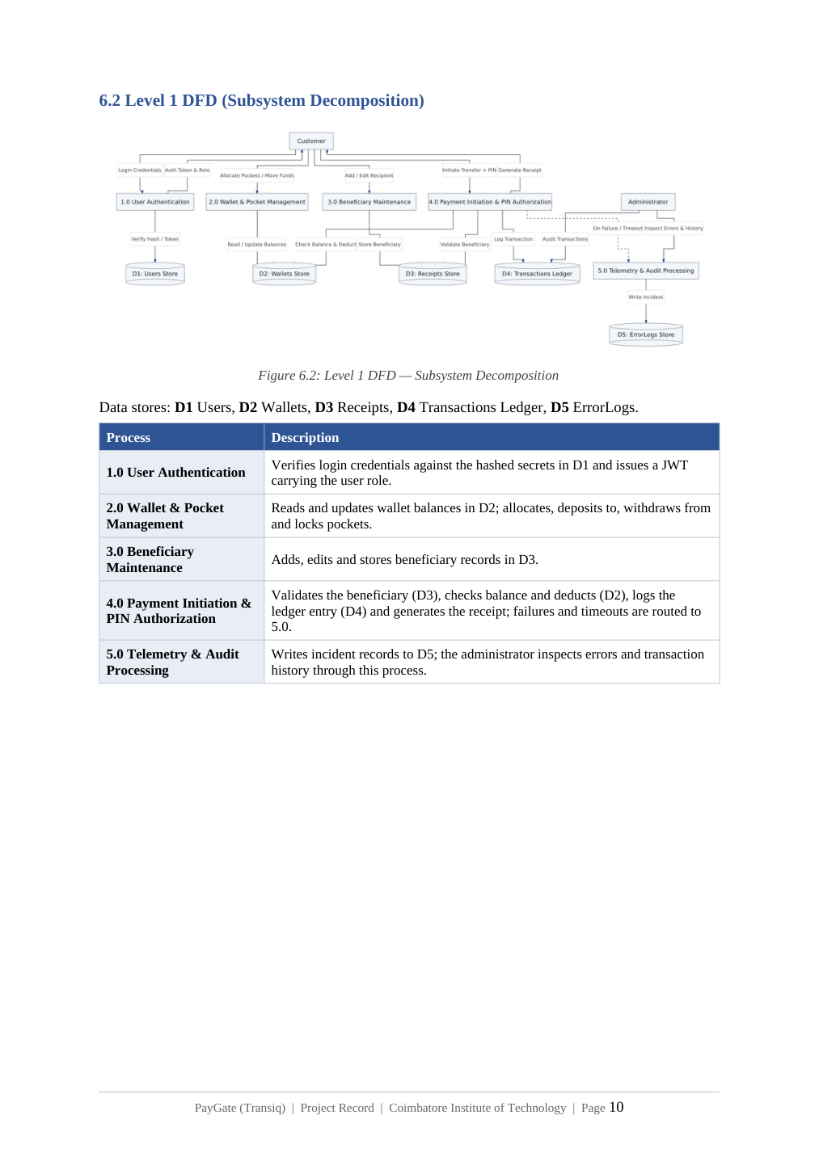
Figure 6.1 — Level 1 DFD: Subsystem Decomposition

7. Entity–Relationship Diagram
The ER model defines the principal entities and relationship cardinalities. A User allocates many Pockets (1:N), saves many Receipts/beneficiaries (1:N), links many Bank Accounts (1:N) and owns exactly one Wallet (1:1). A Wallet originates many Transactions (1:N), a Receipt receives many Transactions (1:N), and a failed Transaction triggers one ErrorLog (1:1).
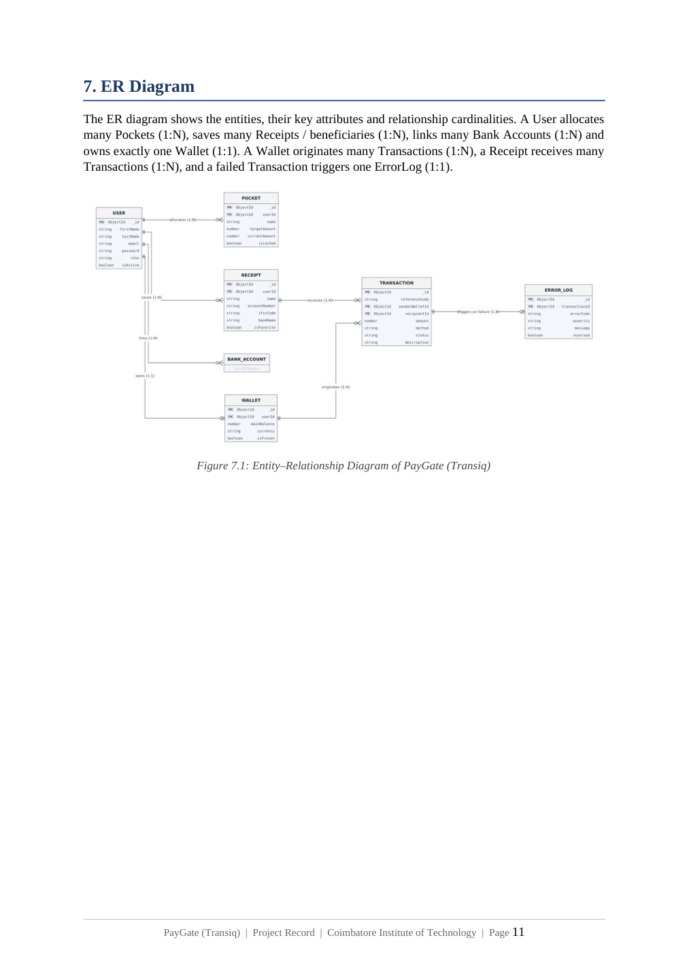
Figure 7.1 — Entity–Relationship Diagram of PayGate (Transiq)

8. Use Case Diagram
Two actors interact with the system: the Customer User, who registers, logs in and performs customer-portal operations, and the System Admin, who monitors telemetry, reviews transactions, inspects error logs and resolves pending transactions.
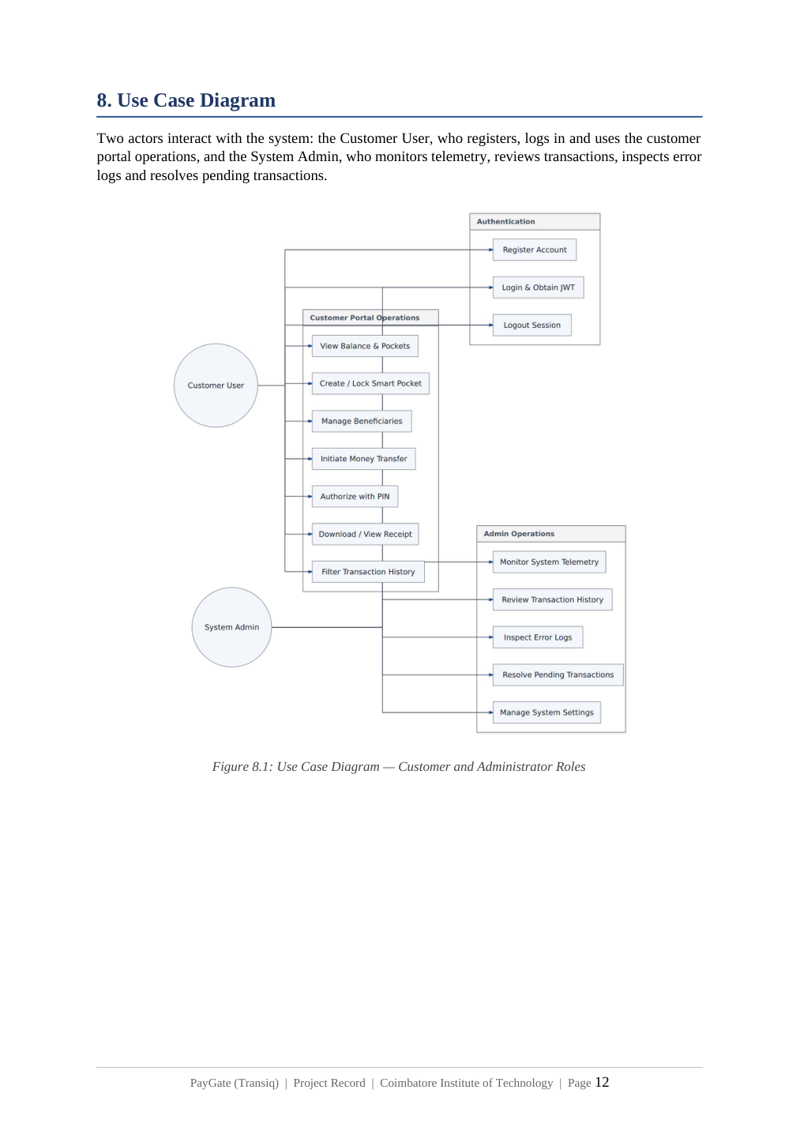
Figure 8.1 — Use Case Diagram: Customer and Administrator Roles

9. Class Diagram
The class model contains the domain classes User, Wallet, Pocket, Receipt, Transaction and ErrorLog, together with PaymentController. The controller creates transactions and updates wallets.
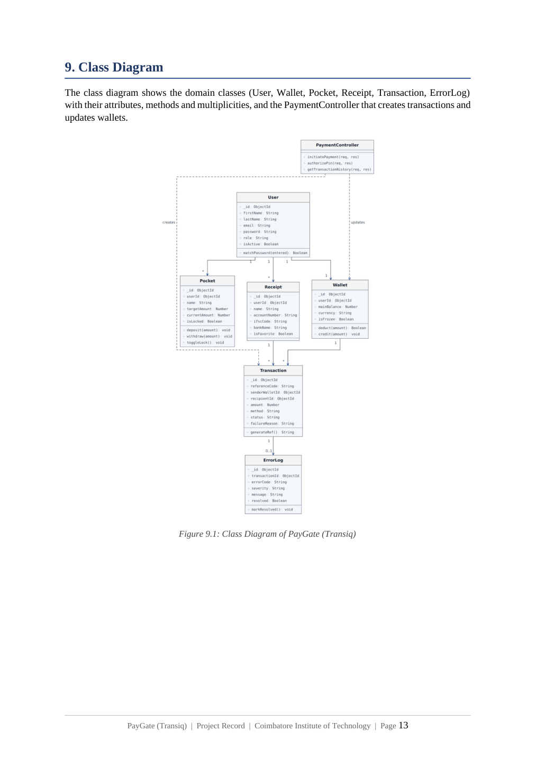
Figure 9.1 — Class Diagram of PayGate (Transiq)

10. Sequence Diagram
The sequence diagram traces payment initiation: PIN submission, JWT verification in the authentication middleware, wallet and balance checks, followed by either an error response with an ErrorLog entry or a successful balance deduction, transaction creation and receipt display.
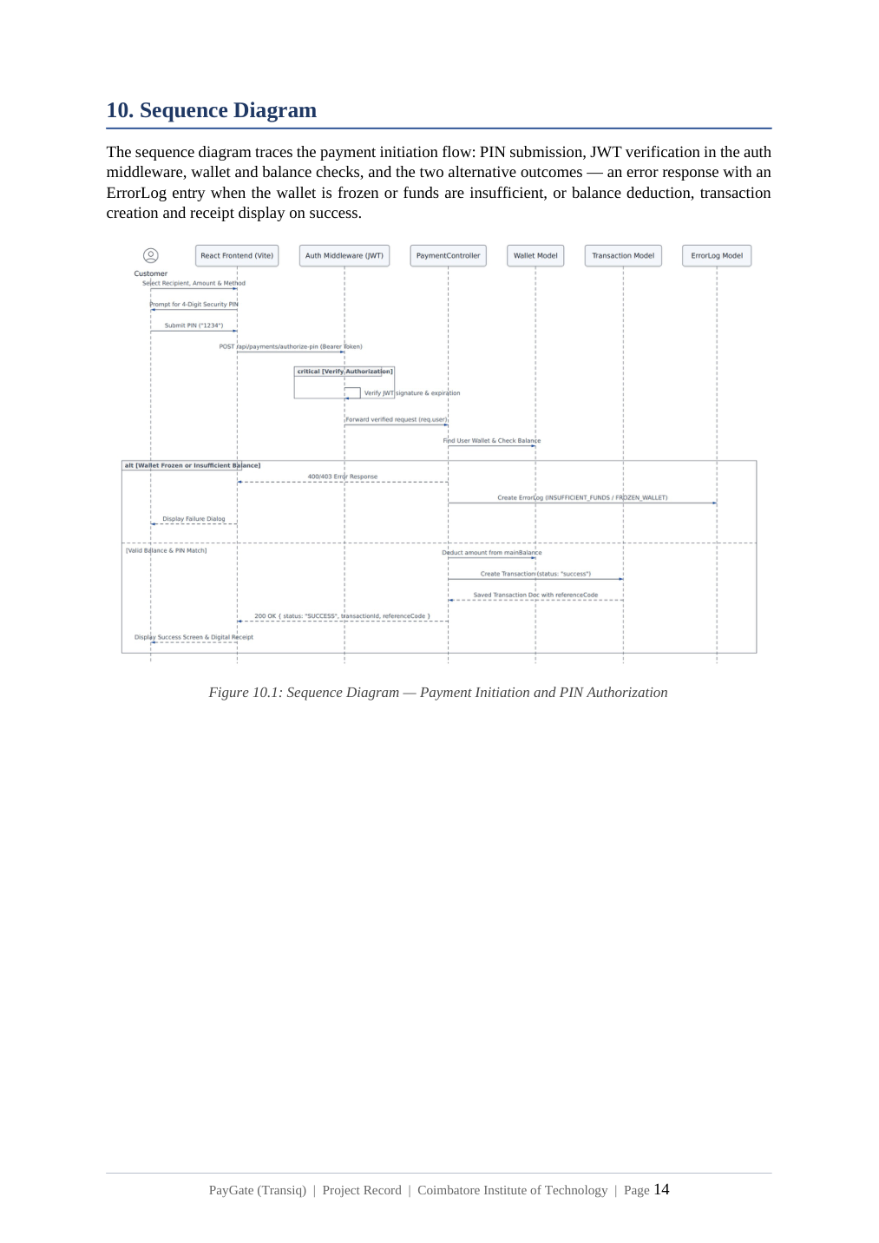
Figure 10.1 — Sequence Diagram: Payment Initiation and PIN Authorization

11. User Interface Screenshots
The project record provides representative screens for the customer and administrator workflows.

11.1 Customer Sign In & Registration
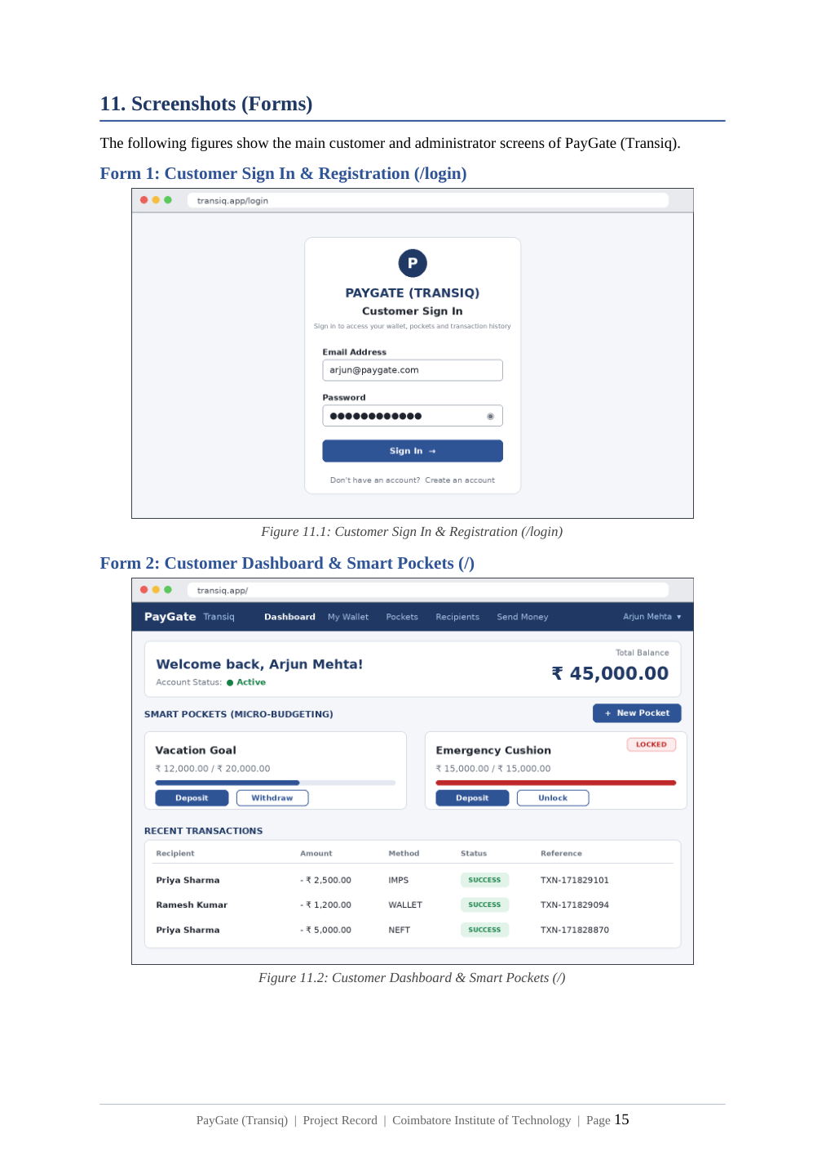
Figure 11.1 — Customer Sign In & Registration; Figure 11.2 — Customer Dashboard & Smart Pockets

11.2 Beneficiary Directory & Payment Checkout
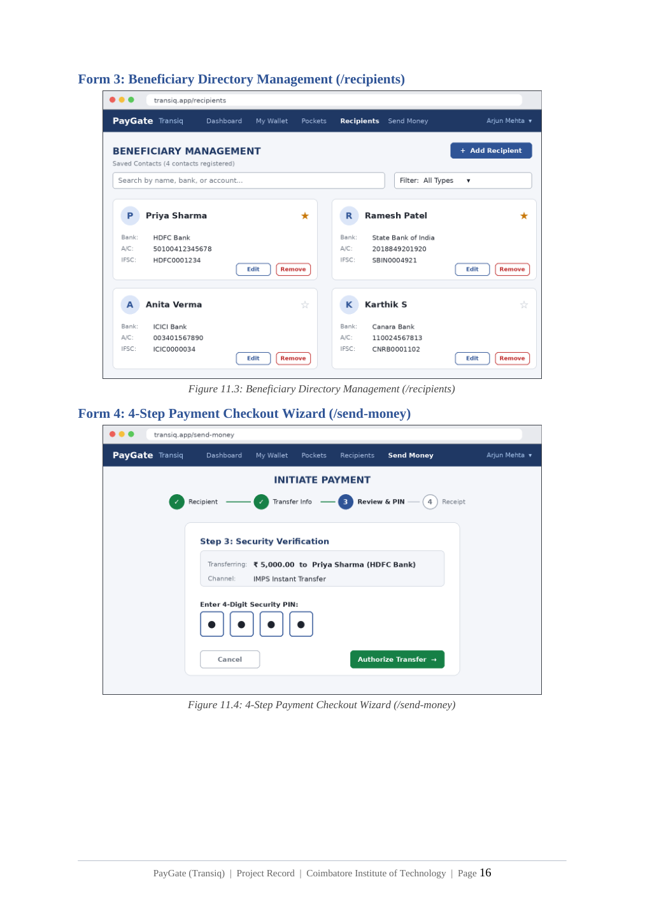
Figure 11.3 — Beneficiary Directory Management; Figure 11.4 — 4-Step Payment Checkout Wizard

11.3 Admin Operations & Error Audit Console
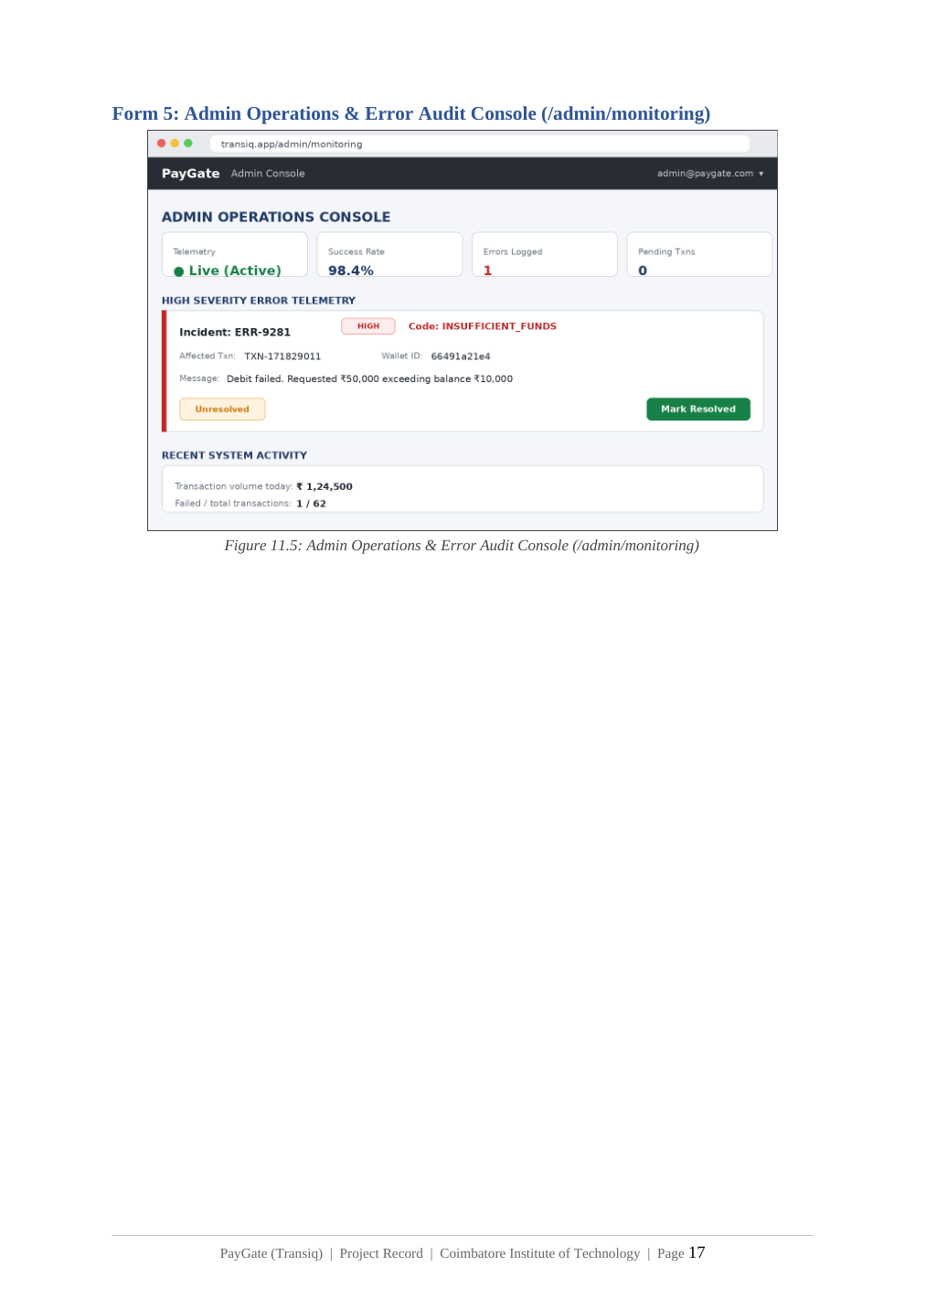
Figure 11.5 — Admin Operations & Error Audit Console

12. Test Report
Testing was conducted using Jest and Supertest covering REST endpoints, validation logic, balance safeguards and security middlewares.

12.1 Test Execution Summary
Metric | Result
Test Runner | Jest v30.5.2 (Node.js ES Modules)
Execution Timestamp | October 2026
Test Suites Run | 2 passed, 2 total
Total Tests Executed | 5 passed, 0 failed, 0 skipped
tests/api.test.js | PASS — health check, role enforcement, duplicate registration and PIN validation
tests/math.test.js | PASS — currency formatting for zero and floating numbers

12.2 Detailed Test Cases
Test ID | Test Description | Input | Expected Output | Actual Result | Status
TC-AUTH-01 | Unauthenticated access to dashboard | Request to / without token | Redirect to /login | Redirected to /login | PASS
TC-AUTH-02 | Customer registration role enforcement | Payload: role='admin' | Backend forces customer role | Created user has customer role | PASS
TC-PAY-01 | PIN authorization with correct PIN | PIN 1234, Amount ₹500 | HTTP 200; balance decremented | Balance updated; TXN created | PASS
TC-PAY-02 | Overdraft / insufficient balance | ₹1,00,000 vs ₹45,000 balance | HTTP 400; insufficient balance | 400 returned; ErrorLog saved | PASS
TC-PAY-03 | Transfer with frozen wallet | isFrozen=true | HTTP 403; transfer blocked | 403 returned; blocked | PASS
TC-LOGS-01 | Automatic ErrorLog on failure | Failed transaction | ErrorLog inserted | Verified in MongoDB | PASS

12.3 Test Execution Evidence
The project record reports 2 passed test suites, 5 passed tests and zero failures/skips, with an execution time of 0.588 seconds.

13. Conclusion and Further Enhancements

13.1 Conclusion
The PayGate (Transiq) project delivers a digital payment and wallet platform by combining a responsive React single-page frontend, an asynchronous Node.js/Express REST backend and MongoDB persistence. The documented design emphasizes transactional integrity through atomic balance deductions, Smart Pocket micro-budgeting, strict role-based routing guards and automated administrative telemetry for payment failures.

13.2 Further Enhancements
- Real-Time WebSockets for Instant Status Updates: integrate Socket.io to push transaction notifications and settlement receipts without polling.
- Biometric & Multi-Factor Authentication (MFA): implement WebAuthn/FIDO2 alongside SMS/Email TOTP.
- AI-Driven Fraud Detection Engine: apply machine-learning classification to transaction risk based on geographic IP shifts, velocity checks and atypical transaction sizes.
- Multi-Currency & International Forex Routing: support cross-border foreign-exchange conversion using ISO 4217 currency pairs and live exchange-rate integration.

14. Team Presentation Plan
The source project record specifies a six-member team. The following division keeps the presentation balanced while allowing the PPT to remain concise.
Member | Presentation Responsibility | Recommended Coverage
Member 1 | Introduction & Problem | Title, synopsis, problem definition, objectives
Member 2 | Scope & Architecture | Scope, MERN stack, three-tier architecture
Member 3 | Database & Design Models | Collections, DFD, ER diagram
Member 4 | Application Workflow | Use cases, class diagram, sequence/payment flow
Member 5 | UI & Security | Screens, authentication, RBAC, wallet controls
Member 6 | Testing & Future Work | Test results, limitations, enhancements, conclusion

15. Likely Viva Questions
Question | Suggested Answer
Why MERN? | It provides a decoupled full-stack architecture using React for the client, Node/Express for REST services and MongoDB/Mongoose for persistence.
Why JWT? | JWT enables stateless authenticated API requests and carries the authenticated role for authorization.
Why bcrypt? | It stores passwords as one-way hashes rather than plaintext secrets.
Why Smart Pockets? | They provide goal-based micro-budgeting with explicit lock/unlock controls.
What happens when payment fails? | The transaction is rejected and categorized ErrorLog telemetry is recorded for administrative audit/recovery.
Why atomic transaction handling? | Balance changes and ledger creation must remain consistent so partial financial updates are avoided.
Is it connected to real banks? | No. The project record explicitly states that real-bank webhook integration is out of scope and mock banking controllers are used.
What is the key contribution? | The system combines controlled payment execution with explicit failure telemetry and administrative recovery visibility.

16. Source Basis
This documentation is prepared directly from the supplied PayGate (Transiq) Project Record. The structure, terminology, architecture, database definitions, diagrams, screenshots, test results and future-enhancement statements are retained from that source rather than replaced with external assumptions.
Primary source: PayGate (Transiq) Project Record, Coimbatore Institute of Technology, 19 pages.
— END OF DOCUMENT —

